
Mini project report on
Personal Credit Health and Debt Repayment Planning System
Submitted in partial fulfilment of the requirements for the award of degree of

Bachelor of Technology
in
Computer Science & Engineering
UE24CS351A – DBMS Project
Submitted by:
Amoghaa R  Adarsha V | PES2UG24CS625  PES2UG24CS621
under the guidance of

Dr. Shilpa S
Assistant Professor
PES University

AUG - DEC 2026
DEPARTMENT OF COMPUTER SCIENCE AND ENGINEERING
FACULTY OF ENGINEERING
PES UNIVERSITY
(Established under Karnataka Act No. 16 of 2013)
Electronic City, Hosur Road, Bengaluru – 560 100, Karnataka, India

PES UNIVERSITY

(Established under Karnataka Act No. 16 of 2013)
Electronic City, Hosur Road, Bengaluru – 560 100, Karnataka, India

CERTIFICATE

This is to certify that the mini project entitled

Personal Credit Health and Debt Repayment Planning System

is a bonafide work carried out by

Amoghaa R  Adarsha V | PES2UG24CS625  PES2UG24CS621

In partial fulfilment for the completion of fifth semester DBMS Project (UE24CS351A) in the Program of Study -Bachelor of Technology in Computer Science and Engineering under rules and regulations of PES University, Bengaluru during the period AUG. 2026 – DEC. 2026. It is certified that all corrections / suggestions indicated for internal assessment have been incorporated in the report. The project has been approved as it satisfies the 5th semester academic requirements in respect of project work.

Signature
Dr. Shilpa S
Assistant Professor

DECLARATION

We hereby declare that the DBMS Project entitled Personal Credit Health and Debt Repayment Planning System
has been carried out by us under the guidance of Dr. Shilpa S, Assistant Professor and submitted in partial fulfilment of the course requirements for the award of degree of Bachelor of Technology in Computer Science and Engineering of PES University, Bengaluru during the academic semester AUG – DEC 2026.

Amoghaa R  Adarsha V | PES2UG24CS625  PES2UG24CS621 | <Signature>  <Signature>

ACKNOWLEDGEMENT

I would like to express my gratitude to Dr. Shilpa S, Department of Computer Science and Engineering, PES University, for her continuous guidance, assistance, and encouragement throughout the development of this UE24CS351A - DBMS Project.
I take this opportunity to thank Dr. Sandesh B J, C, Professor, Chairperson, Department of Computer Science and Engineering, PES University, for all the knowledge and support I have received from the department.
I am deeply grateful to Prof. Jawahar Doreswamy, Chancellor – PES University, Dr. Suryaprasad J, Vice-Chancellor, PES University for providing to me various opportunities and enlightenment every step of the way. Finally, this DBMS Project could not have been completed without the continual support and encouragement I have received from my family and friends.

ABSTRACT
The Personal Credit Health and Debt Repayment Planning System is a database-oriented project designed to centralize personal financial information and support effective debt repayment management.
The system maintains information related to users, financial profiles, loans, repayments, credit scores and repayment plans. A relational database is designed using an Entity Relationship model and implemented using MySQL.
The project demonstrates database concepts through DDL and DML statements, primary and foreign key constraints, SQL queries, transactions, stored procedures, triggers and indexing.
The proposed system provides a structured approach to managing financial records, monitoring repayment activities and organizing repayment plans. It demonstrates how database management concepts can be applied to a real-world personal financial management problem.

TABLE OF CONTENTS

Chapter No. | Title | Page No.
 | INTRODUCTION | 9
 | PROBLEM DEFINITION | 10
 | ER MODEL | 11
 | ER TO RELATIONAL MAPPING | 12
 | DDL STATEMENTS | 13
 | DML STATEMENTS | 20
 | QUERIES (SIMPLE QUERY AND UPDATE AND DELETE OPERATION, CORRELATED QUERY AND NESTED QUERY) | 23
 | STORED PROCEDURE, FUNCTIONS AND TRIGGERS | 25
 | FRONT END DEVELOPMENT | 28
REFERENCES/BIBLIOGRAPHY |  | 28
LIST OF TABLES

Table no | Title
5.1
  USER Table
5.2
  FINANCIAL_PROFILE Table
5.3
  LOAN Table
5.4
  REPAYMENT Table
5.5
  REPAYMENT_PLAN Table
5.6
  PLAN_PAYMENT Table

LIST OF FIGURES
Figure No | Title
6.1 | Insertion of USER Record
6.2
  Insertion of FINANCIAL_PROFILE Record
6.3 | Insertion of LOAN Record
6.4 | Insertion of REPAYMENT_PLAN Record
6.5 | Insertion of PLAN_PAYMENT Record

1. INTRODUCTION
Personal financial management involves maintaining information about income, expenses, bank accounts, loans, credit scores and repayment activities. When this information is maintained separately, individuals may find it difficult to understand their overall financial position and manage repayment obligations effectively.
The Personal Credit Health and Debt Repayment Planning System is designed to provide a centralized database for organizing and managing personal financial information. It maintains user details, financial profiles, loan records, repayment history and repayment plans.
The system uses a relational database implemented in MySQL. Primary keys, foreign keys and integrity constraints maintain consistency between related records. SQL queries and database operations support financial analysis, repayment tracking and the management of repayment plans.
Objectives:
- To maintain centralized personal financial records.
- To store and manage loan and repayment information.
- To monitor repayment status and outstanding amounts.
- To maintain financial and credit-related information.
- To support the creation and management of repayment plans.
- To demonstrate database operations and advanced SQL concepts.

2. PROBLEM DEFINITION
Individuals often face difficulties managing their financial information because income, expenses, loans, credit scores and repayment records are maintained separately.

The absence of a centralized system makes it difficult to track outstanding loan amounts, monitor repayment deadlines, evaluate financial conditions and organize repayment priorities.
The proposed system addresses this problem by developing a relational database that stores personal financial information and maintains relationships between users, financial profiles, loans, repayments and repayment plans.

Proposed Solution:
The system provides a centralized MySQL database that allows financial records to be stored, updated, retrieved and analyzed using SQL operations. It also supports repayment planning and monitoring through related database tables.

3. ER MODEL

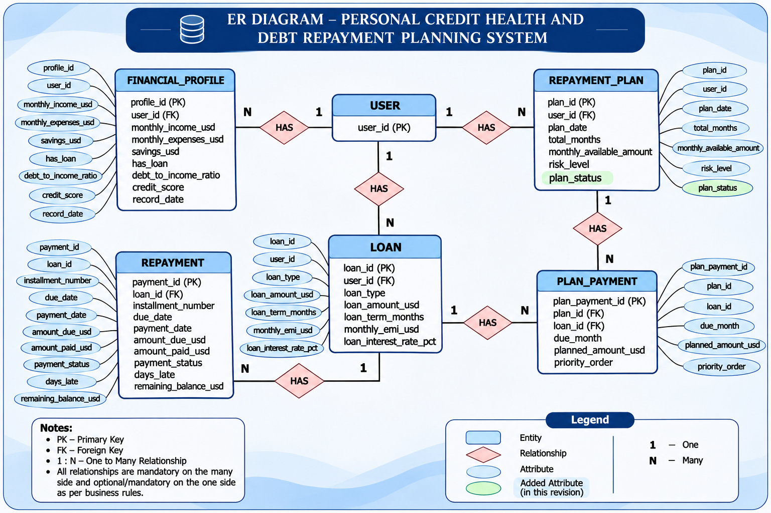

4. ER TO RELATIONAL MAPPING

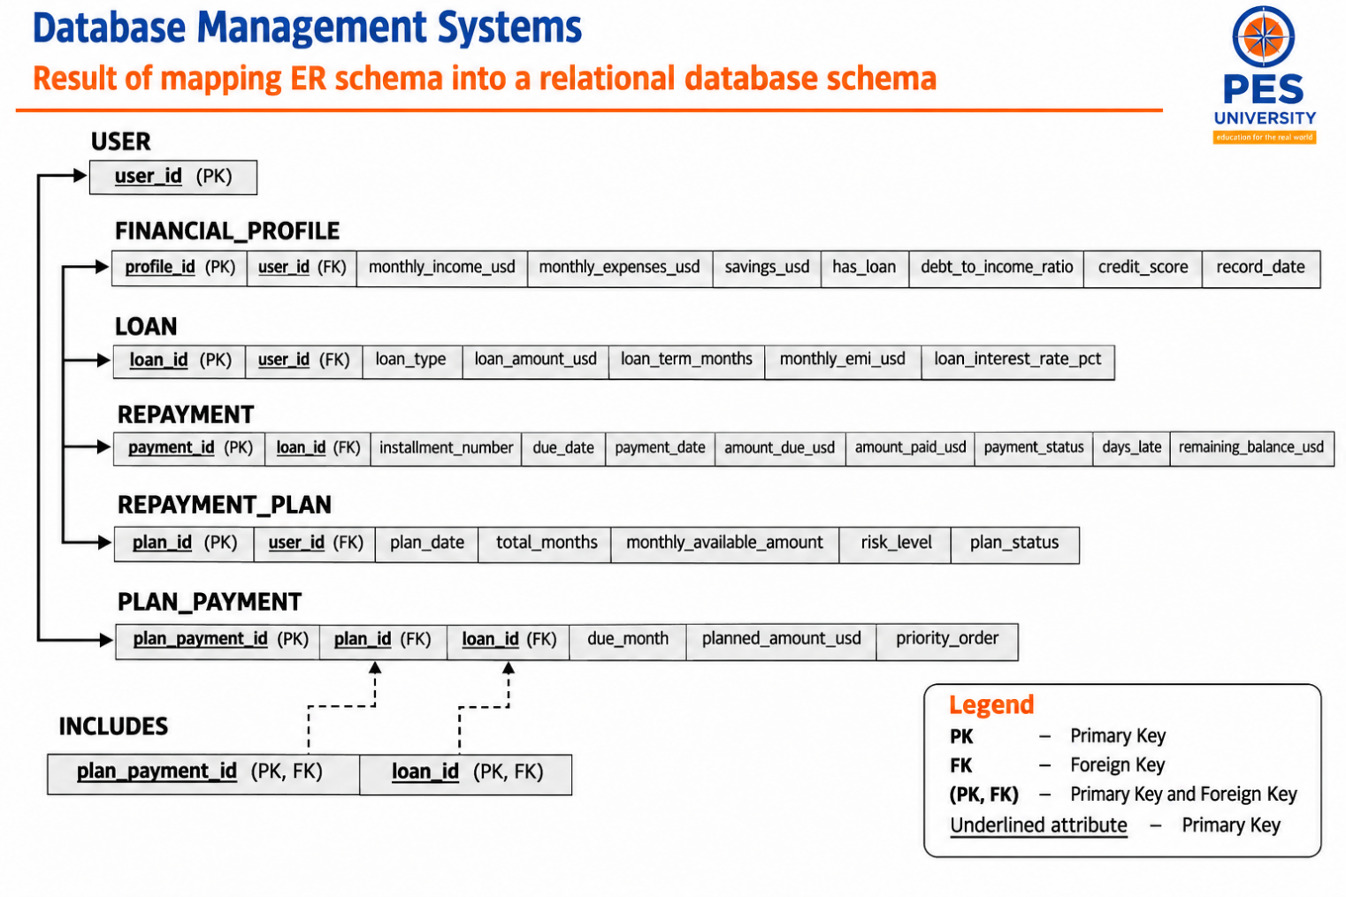

5. DDL STATEMENTS

STATEMENTS WITH SCREEN SHOTS OF THE TABLE CREATION

5.1 Database Creation and Selection
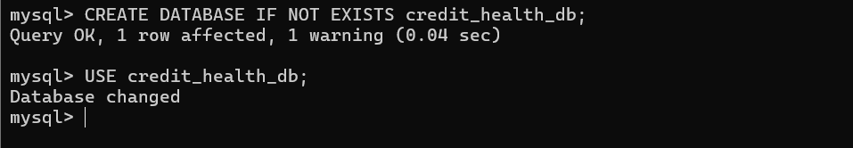
5.2 Creation of USER Table
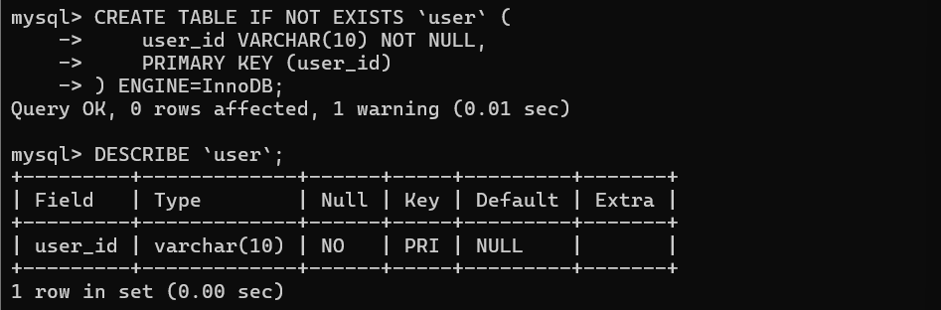

5.3 Creation of FINANCIAL_PROFILE Table
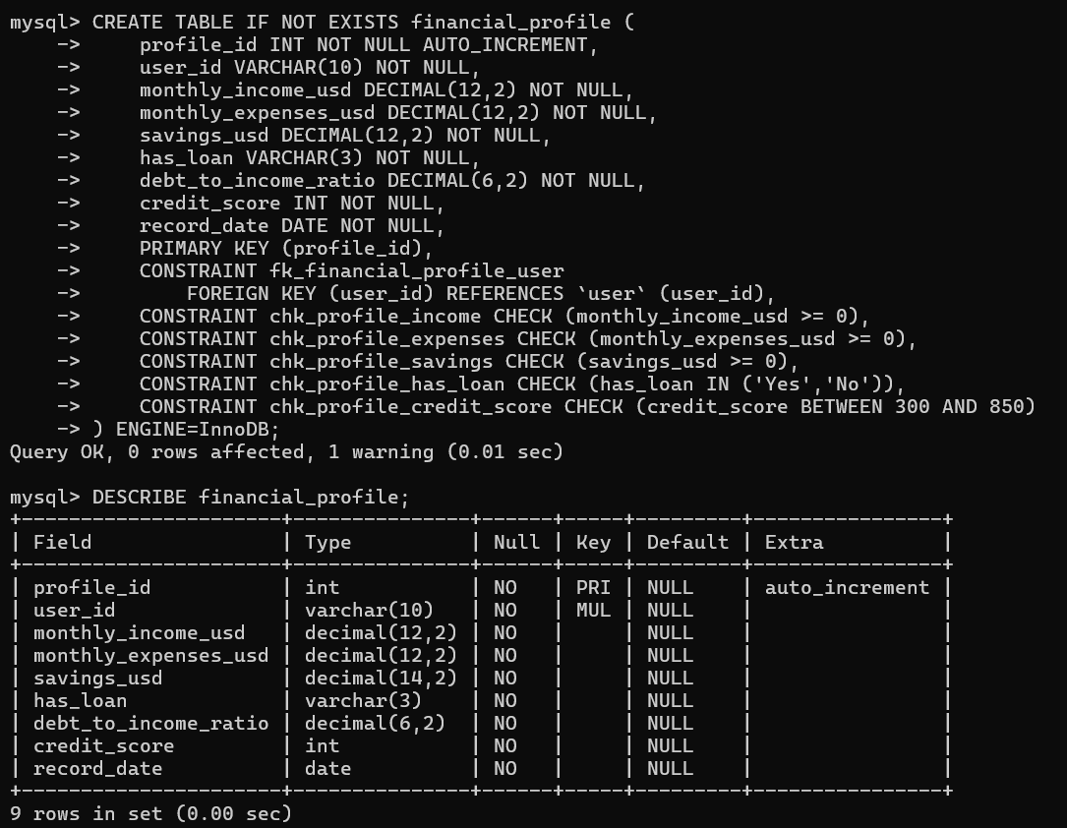

5.4 Creation of LOAN Table
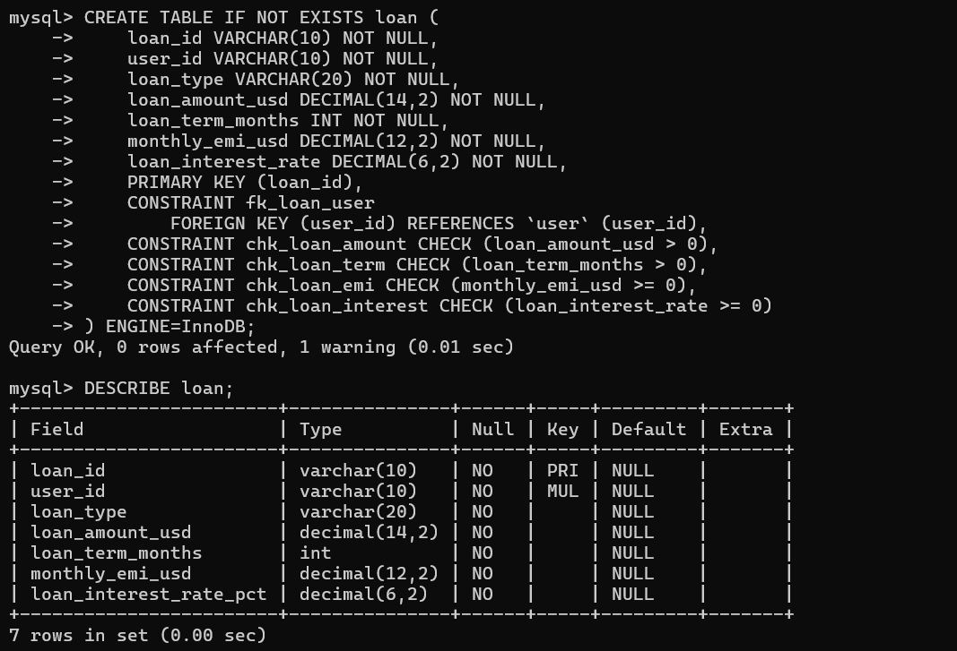

5.5 Creation of REPAYMENT Table
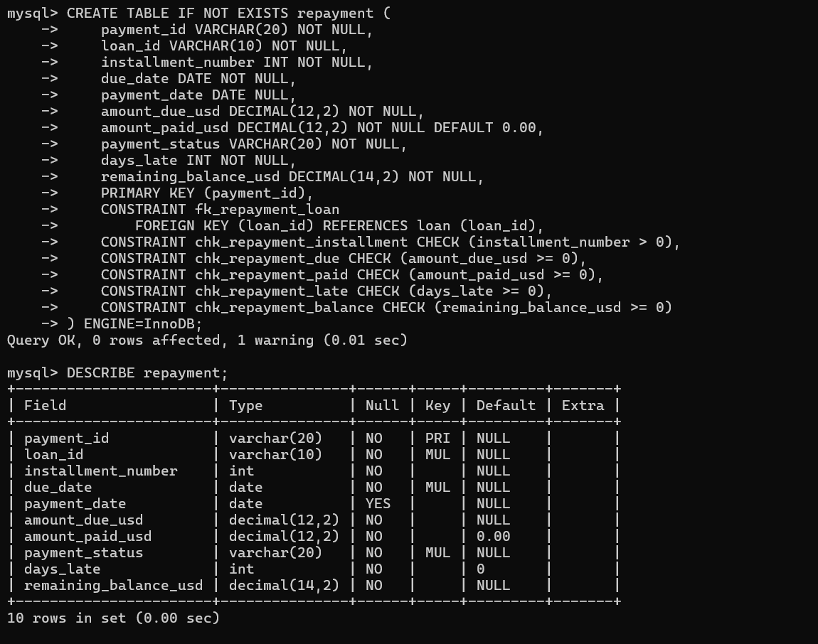

5.6 Creation of REPAYMENT_PLAN Table
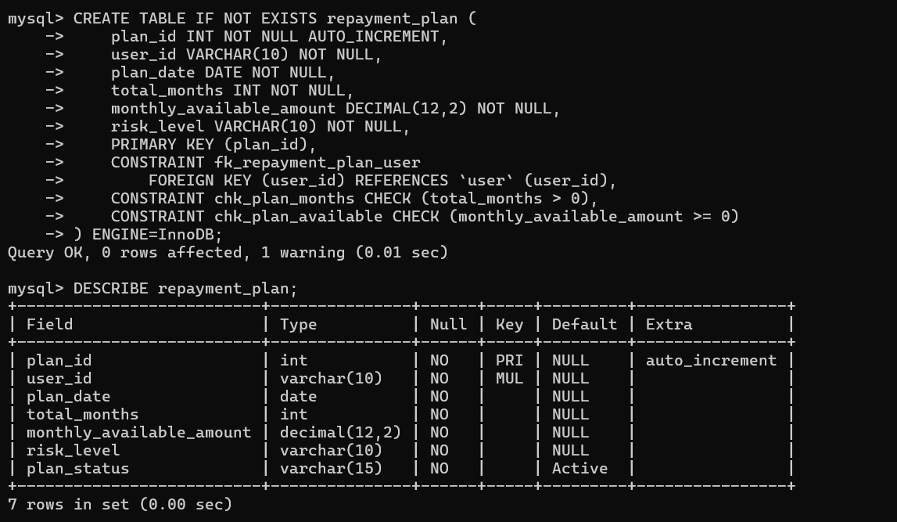

5.7 Creation of PLAN_PAYMENT Table
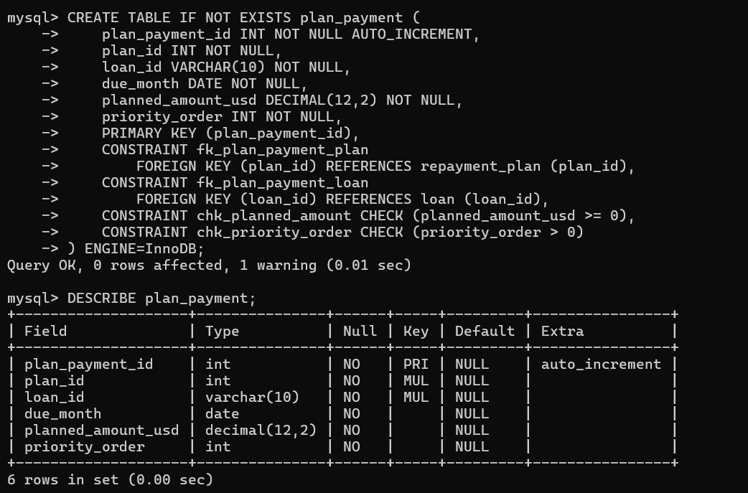

6. DML STATEMENTS

STATEMENTS WITH SCREEN SHOTS OF THE TABLE WITH INSERTED VALUES
6.1 Insertion of USER Record
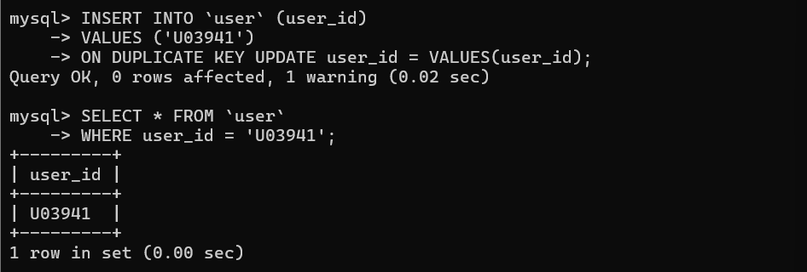

6.2 Insertion of FINANCIAL_PROFILE Record
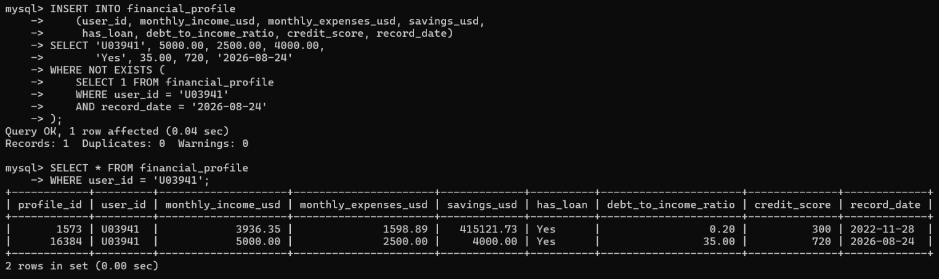

6.3 Insertion of LOAN Record
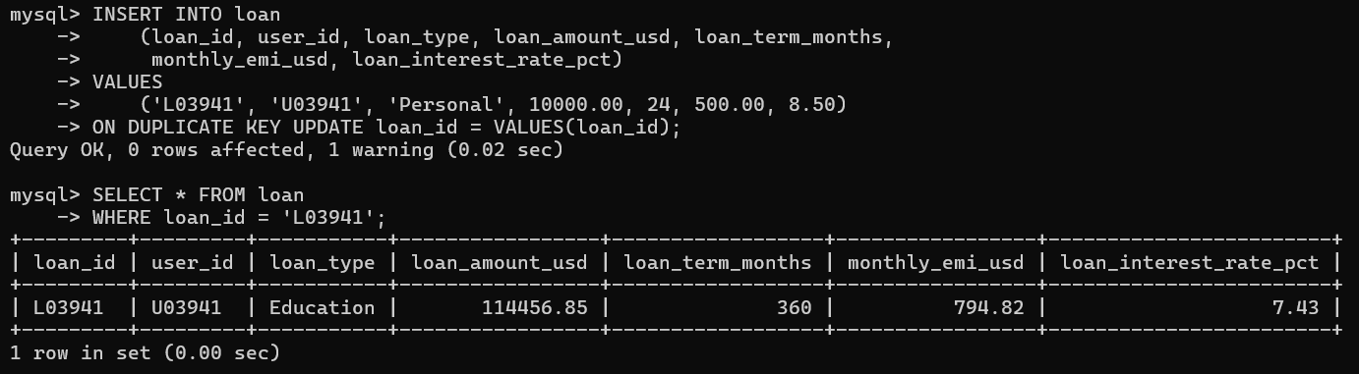

6.4 Insertion of REPAYMENT_PLAN Record
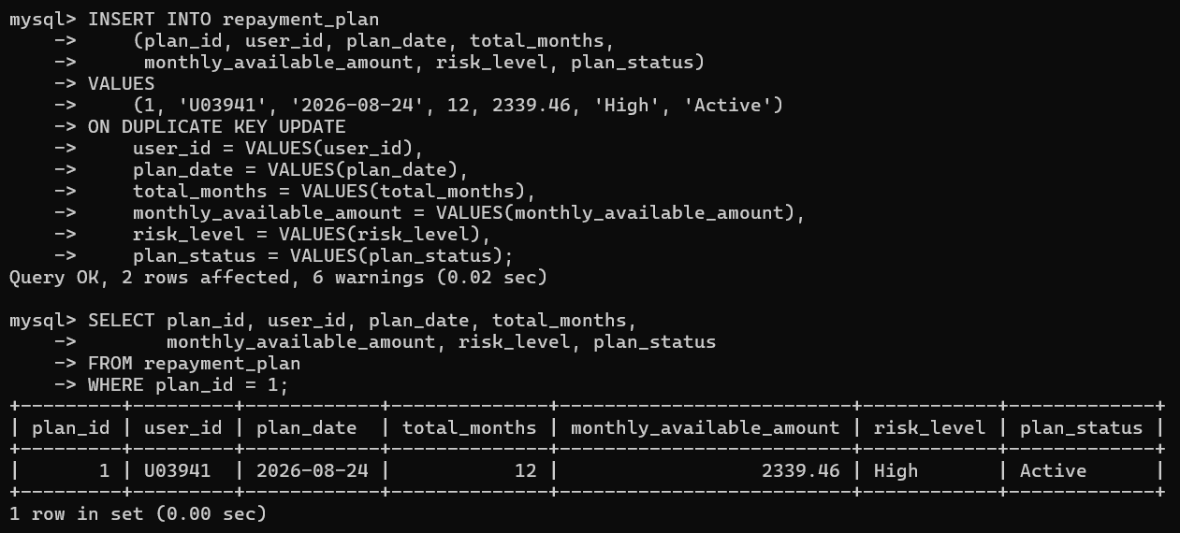

6.5 Insertion of PLAN_PAYMENT Record
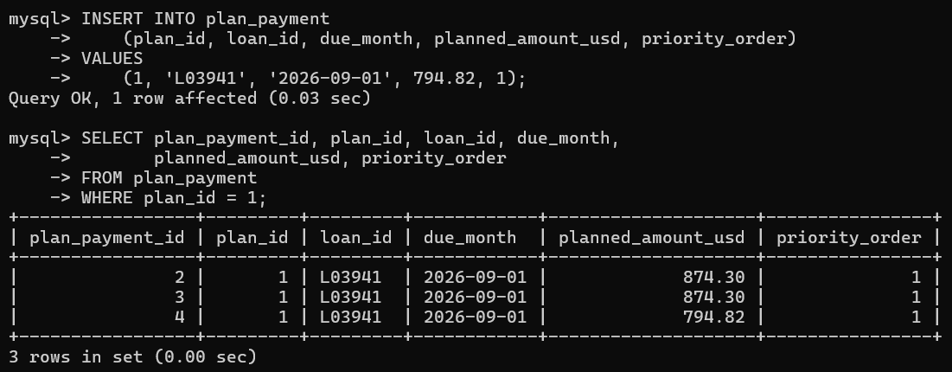

7. QUERIES
7.1 Grouping Loans by Type Using Aggregate Functions
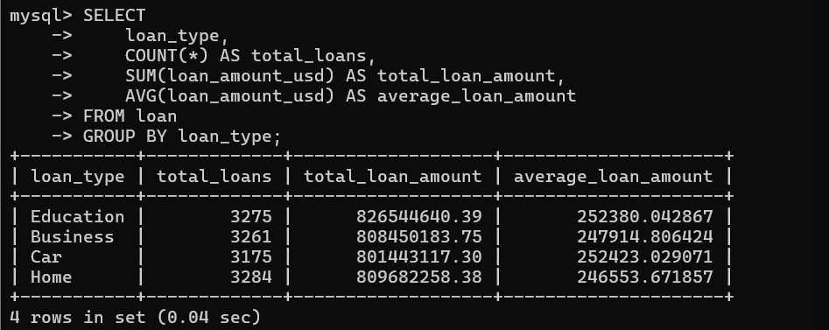

7.2 Updating the Planned Payment Amount
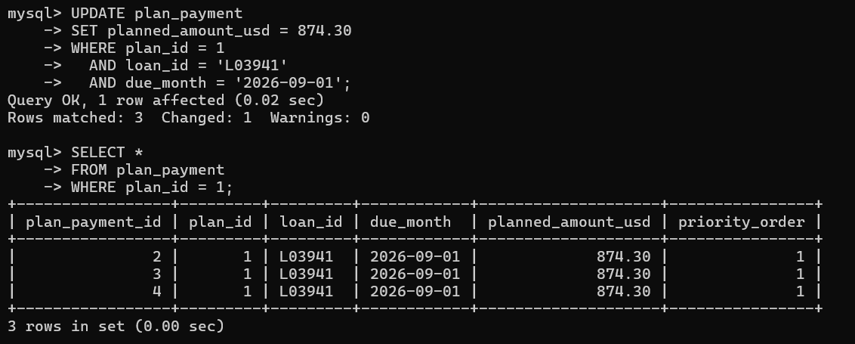

7.3 Deleting a Planned Payment Record
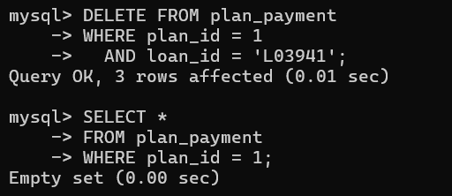

7.4 Retrieving Loan Details Using a Correlated Subquery
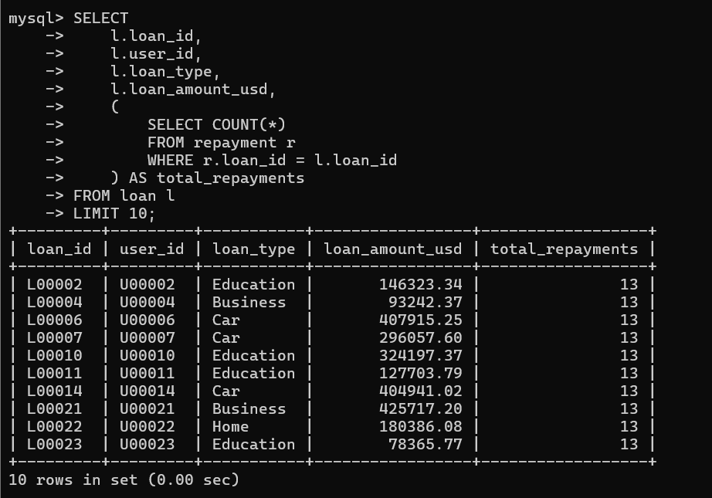

7.5 Retrieving Financial Profiles Using a Nested Query
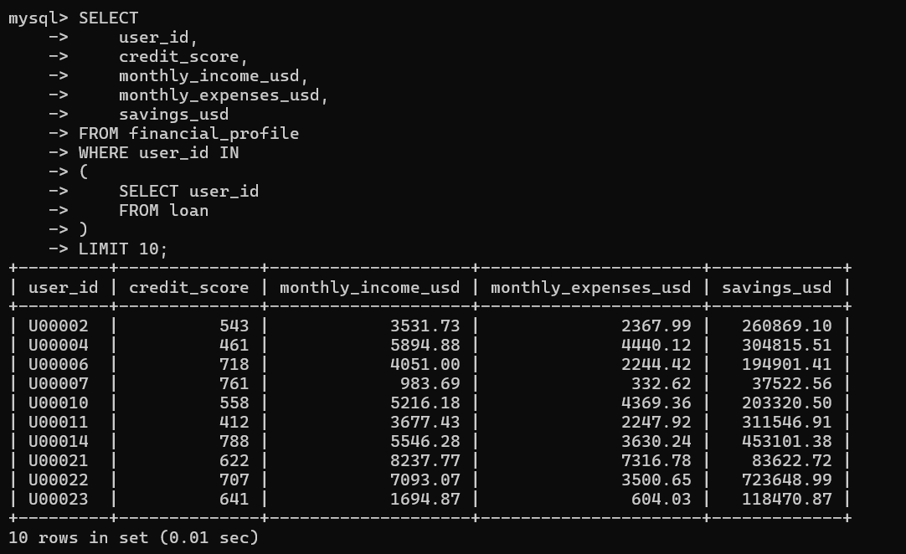

8. STORED PROCEDURES, FUNCTIONS AND TRIGGERS
8.1 STORED PROCEDURES OR FUNCTIONS

8.1.1 Stored Procedure Creation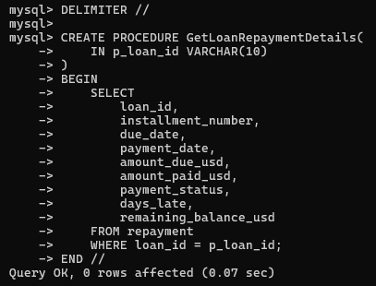

8.1.2 Stored Procedure Execution
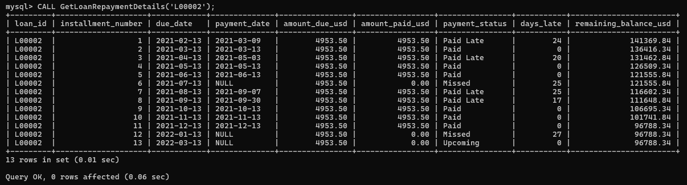

8.1.3 Stored Procedure Verification

8.2 TRIGGERS
8.2.1 Trigger to Automatically Calculate Days Late
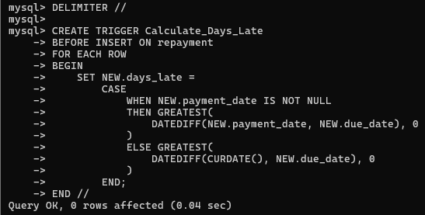
8.2.2 Trigger Verification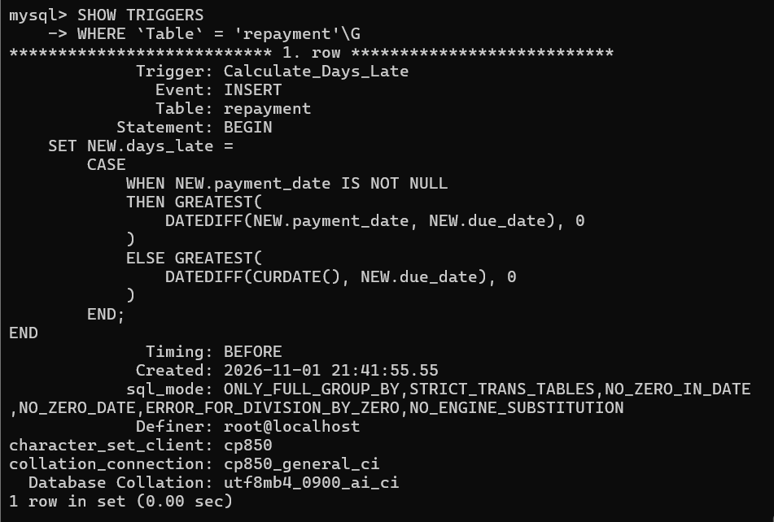

9. FRONT END DEVELOPEMNT

REFERENCES

[1]

GitHub Link:

